
Department of BES-1
DATA STRUCTURES UISNG PYTHON

I/IV-B.Tech-(II Sem), Academic Year: 2024-2025

Session-8 (External Sorting)
Instructional Objective:
- To learn the concept ofExternal Sorting.
- To find Time complexity of External Sort Algorithm.

Learning Outcomes:
- Able to implement External Sort Mechanism.
- Able to find Time complexity.

Introduction:
A Sorting Algorithm is used to rearrange a given array or list elements in either ascending order or descending order according to comparison operator.

Explanation: External Sorting is applied on data set which acquire large memory which cannot be hold in main memory (RAM) and is stored in secondary memory ( hard disk). External merge sort uses a hybrid sort-merge technique. The chunks of data small enough to fit in the RAM are read, sorted, and written out to a temporary file during the sorting phase. In the merge phase, the sorted sub-files are combined into a single larger file.
- The idea of sorting used in external sort is quite similar tomerge sort. In also possess two phases like in merge sort
- In the sort phase, small memory size data sets are sorted and then in merge phase, these are combined to a single dataset.
For a huge data set which cannot be processed in a single go. Data is divided into small chunks. These chunks are sorted and then stored in data files.

Example:1
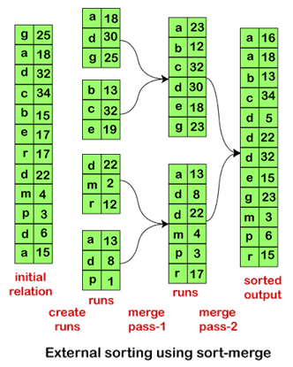

Algorithm:
1.Read the input data from the file and input it as data sets of size of memory.
2. For each of these mini data sets sorted each of them using merge sort.
3. Store the sorted data into a file.
4. Merge each of the sorted data file

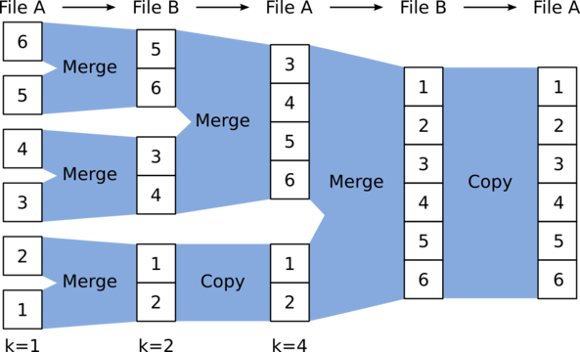

Advantages and Applications of External Sorting:
Advantages | Applications
Efficient for Large Datasets | Database Management Systems (DBMS)
Optimized for Disk I/O | Data Warehousing
Scalable for Big Data | Search Engines
Parallelizable | Distributed Computing and Big Data (Hadoop, Spark)
Reduced Memory Requirements | Large-scale File Processing
Adapts to Various Storage Media | File Systems (video editing, multimedia)
Efficient Merging | Data Mining
Handles Limited RAM | Machine Learning (Preprocessing)
 | Log File Analysis
 | Compression Algorithms
 | Cloud-based Data Processing

Time Complexity of External Sort Algorithm in Python
The time complexity of external sorting depends on various factors, primarily the number of data elements (n), the number of chunks (or "runs") created from the data (k), the sorting method used within each chunk (often Insertion Sort or Merge Sort), and the number of passes over the data.
- Time Complexity of External Sorting: O(nlog⁡n) where n is the number of elements to be sorted.
- Space Complexity: O(m+k) where m is the chunk size (elements that can be loaded into memory) and k is the number of runs.
External sorting is efficient for sorting very large datasets that cannot fit into memory, but its performance depends heavily on the memory available for chunking and how well the I/O operations are optimized.

Self-assessment questions:
- External-sort merge algorithm is called an ___ because it merges N runs.
a.one-way
b.Tw-way
c.Null-way
d.N-way
- There will either be M or more runs generated depending on the size of the ___.
a.Relation
b.Memory
c.Botha and b.
d.None of the above

Terminal questions
CLASSROOM DELIVERY PROBLEMS

- Describe External Sorting Algorithm in detail.
- List out Advantages and applications of External Sort Algorithm.
- Summarize External Sort Algorithm and compare with remaining sorting techniques.
- ExplainExternalsortingandtwophasesofexternalsorting(1.Sortphase 2.Merge phase)withanexample.

PRACTICE PROBLEMS

- Implement External sort mechanism on the below list of elements
- 4 22 47 33 27 87 99 55 09 06.
- Analyze Time complexity of External Sort Algorithm.
- WriteandExecuteaCprogramtosolvethefollowingexample.
N=14,M=3(14 recordsontapeTa1,memorycapacity:3records.)
T1:17,3,29, 56, 24, 18, 4, 9,10, 6,45,36,11,43

Department of BES-1

Data Structures Using Python
I/IV-B.Tech-(IISem), Academic Year: 2024-2025

Session - 8 (Bucket Sort)
Instructional Objective:
- Demonstrate : Bucket Sort Approach
- Describe : Bucket Sort algorithm
- Describe the : Time complexity of Bucket sort

Learning Outcomes:
- Define Bucket sort algorithm
- Describe Time complexity of bucket sort
- Summarize Bucket sort algorithm

Introduction:
- Bucket sort works on uniformly distributed data and puts numbers into buckets to sort and gather them all to form the sorted array.
- Bucket sort is also known as bin sort. It is a sorting algorithm that divides an array’s items into a number of buckets.
- The buckets are then sorted one at a time, either using a separate sorting method or by recursively applying the bucket sorting algorithm.
- While conventional sorting algorithms can reach the best case time complexity of O(nlogn), Bucket sort can do the same in O(n).

Uniformly Distributed Data
- Uniformly distributed data has difference between every adjacent element almost the same.
- An array is said to be uniformly distributed if the difference between each adjacent element inside the array is almost the same. Or, in other terms, the elements of the array spread evenly throughout the whole span/range of the array.
For example:
- Consider this array: [10, 21, 29, 41, 52] The difference between each adjacent term is almost equal to 10. Hence, this array has uniformly distributed data and can be sorted using the bucket sort algorithm.
- Consider another array: [1,4,23,5,44,9,6,43] This array is not uniformly distributed because the number of elements between the range [0-10] = 5 (i.e., 1,4,5,9, and 6), whereas the number of elements between [10-20] is 0, and the same for the range [30-40]. The data is scattered over different data ranges but is concentrated within some specific ranges, whereas sparse among the others. Hence, this array is not uniformly distributed.
- This is how a uniform distribution data looks like: The complete data is scattered equally within each range and hence depicts uniformly distributed data.
Scatter-Gather-Approach
- Solving large and complex problems can be a little hard at times. Scatter-gather-approach tries to simplify such complex problems by first scattering the complete data into clusters, solving these sub-problems individually, and finally gathering them all together to get the final result. This is how Bucket sort uses scatter-gather-approach:
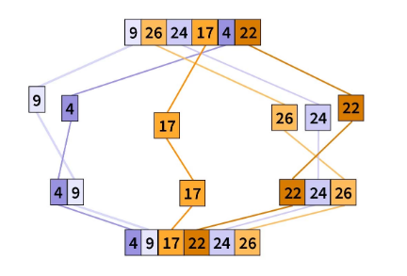

Bucket Sort Algorithm
- Works on Uniformly Distributed data
- Follows Scatter-Gather-Approach
- Sorting technique with time complexity O(n)
- Bucket sort is a sorting technique that uses the Scatter-Gather-Approach to sort the array. It divides the unsorted array into separate groups and calls them buckets. Sort the individual buckets, and then gather them all together to form the final sorted array.
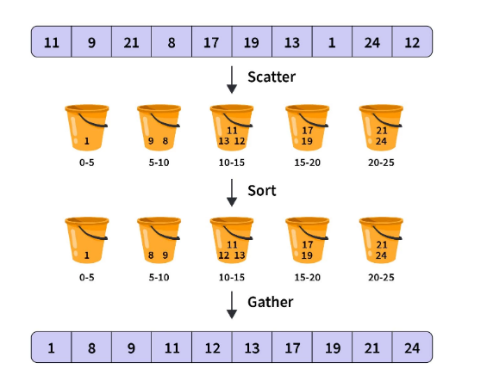

Algorithm
bucketSorting(arr, n):
- Create n empty buckets
- loop through each element of the arr and do the following
Calculate bucketIndex
Insert the element into the corresponding bucket number
- Sort the individual buckets
- Gather all the elements together

Applications in Real Life:
- Sorting Floating-Point Numbers: Bucket sort is ideal when you need to sort floating-point numbers that are uniformly distributed over a known range, such as in scientific simulations, image processing, or data normalization tasks.
- Sorting Large Datasets: For large datasets that are expected to be uniformly distributed across a range, bucket sort can be significantly faster than comparison-based algorithms like quicksort or mergesort.
- Parallel Processing: Since each bucket can be sorted independently, bucket sort can be easily parallelized to take advantage of multiple processors or cores, making it suitable for distributed systems and big data applications.

Advantages of Bucket Sort:
- Efficient for Uniformly Distributed Data: It works best when data is uniformly distributed across a known range.
- Potential for Parallelization: Sorting of individual buckets can be done independently, making it easier to parallelize the sorting process.

Disadvantages of Bucket Sort:
- Not Ideal for Skewed Data: If the data is not uniformly distributed, the performance of bucket sort can degrade to O(n^2), similar to insertion sort.
- Space Complexity: Bucket sort requires additional space for storing the buckets, which can be an issue for large datasets.
- Not Comparison-based: It is only efficient when the data falls within a specific range and is relatively uniformly distributed, making it unsuitable for all types of data.
- Best Case: O(n) (when the input is uniformly distributed and bucket sizes are small).
- Average Case: O(n + n^2 / k), which can be close to O(n) if k is chosen optimally.
- Worst Case: O(n^2) (if all elements are placed into a single bucket).
- Space Complexity: O(n + k), where n is the number of elements and k is the number of buckets.
Bucket Sort is very efficient when the input is uniformly distributed over a range, but it is not suitable for arbitrary distributions unless specific optimizations are made.
Summary of Bucket Sort Complexity:
Aspect | Time Complexity | Space Complexity

Best Case | O(n) | O(n + k)

Worst Case | O(n^2) | O(n + k)

Average Case | O(n + n^2 / k) | O(n + k)

Self-assessment questions:
- What is the alternate name of bucket sort?
a) group sort
b) radix sort
c) bin sort
d) uniform sort
- Bucket sort is most efficient in the case when __________
a) The input is non uniformly distributed
b) the input is uniformly distributed
c) the input is randomly distributed
d) the input range is large

CLASSROOM DELIVARY PROBLEMS

- Explain Bucket sort and its basics with an example.
- Compare Bucket Sort Algorithm With Other Algorithms
PRACTICE PROBLEMS

- Ask the students to sort the following data using bucket sort: 55,11,22,99,55,33, 77,88, 33
- Analyze the complexity of bucket sort algorithm.

